Cookery Requirements Document

Dempsey Evans

Capstone Project Requirements Document

Grand Canyon University

Professor Landreth

Revision: 2

May 18th, 2025

**ABSTRACT**

The Cookery Application aims to create a space where users can manage their recipes and ingredients effectively. By allowing users to create their own profile and recipes, the users have more control over their experience while using the application. Cookery also aims to support the meal planning process by including ingredient price ranges for meal cost tracking and including a recipe generator feature. Using the recipe generator the user will have the opportunity to generate recipes based on available ingredients. This eliminates stress in last minute meal planning and encourages users to lessen their food waste by using what they have on hand.

The main application functionality is user registration and login, recipe management, ingredient management, and a recipe generator for randomized recipes or recipes based on user given criteria. User authentication will allow each user to have their own protected account and recipes. Users will be able to manage recipes and ingredients by creating, editing, viewing, and deleting them. Simple management functionality will provide consistency that will make the recipes and ingredients easy to read and navigate.

By creating a platform for recipe management users will be able to house their recipes in one place, saving time searching for recipes across numerous websites and books. It saves the user time and energy on what is an important yet typically time-consuming and repetitive process. Providing the users with recipe costs allows the application to act as a tool when meal planning on a budget and the recipe generator allows them to save money by using what they have.

Application growth will be strongly based on user feedback. Users will be able to easily provide feedback on their user profile when logged into the application. By focusing on user needs the application will be able to continue to act as a useful tool for meal management as users and needs change.

|  |
| --- |
| History and Signoff Sheet |

**Change Record**

|  |  |  |
| --- | --- | --- |
| **Date** | **Author** | **Revision Notes** |
| 11/17/2024 | Dempsey Evans | Initial draft for review/discussion |
| 05/13/2025 | Dempsey Evans | Milestone 6 Final review |
|  |  |  |

|  |
| --- |
| **Overall Instructor Feedback/Comments** |

|  |
| --- |
| **Overall Instructor Feedback/Comments** |

**Integrated Instructor Feedback into Project Documentation**

Yes  No

**TABLE OF CONTENTS**

Functional Requirements 5

Non-Functional Requirements 7

Technical Requirements 8

Logical System Design 9

User Interface Design 11

Reports Design 17

Functional Requirements

**Use Cases**

User Stories

|  |  |  |  |  |  |
| --- | --- | --- | --- | --- | --- |
| **ID** | **Feature** | **As a(n) <actor>** | **I would like to <description>** | **So that <outcome>** | **Estimate** |
| 1 | Registration | User | Register on application before login | New users can get a username and password | 5 |
| 2 | Login | User | Input my username and password | Users can access the application | 3 |
| 3 | Create Recipe | User | Create recipe | Users can store recipes long term | 5 |
| 4 | Recipe Deletion | User | Delete existing recipes | Users can remove unwanted recipes | 3 |
| 5 | Recipe Editing | User | Edit recipes | Users can fix or modify recipes | 4 |
| 6 | Recipe Search | User | Search for an existing recipe | Users can quickly locate desired recipes | 5 |
| 7 | Recipe View | User | View the recipe details | Users can follow the recipe | 3 |
| 8 | Recipe Home View | User | I can view my recipes as one list | Users can easily and quickly view all existing recipes | 3 |
| 9 | Create Ingredients | User | Add ingredients for future use | Make creating new recipes quicker | 4 |
| 10 | Recipe Price | User | Know the total cost of each recipe | Users can meal plan on a budget more efficiently | 4 |
| 11 | Ingredient Price | User | Add prices for each ingredient | Recipe costs can be calculated | 4 |
| 12 | Ingredient Deletion | User | Delete ingredients | Users can remove unwanted ingredients | 3 |
| 13 | Ingredient Editing | User | Edit ingredients | Users can fix or modify ingredients | 4 |
| 15 | Password Recovery | User | Reset my password | Users can gain access to their account | 3 |
| 16 | User Information Management | User | Update my user information | User information is always accurate | 4 |
| 17 | User Feedback | User | Provide feedback on the application | The application can be improved | 3 |
| 20 | Recipe Generator | User | Generate recipes based on available ingredients | Users can find recipes they can make | 8 |
| 21 | Recipe Generator View | User | I would like to have a user-friendly interface to use the generator | Users can use the generator effectively | 3 |
| 23 | IngredientQuantity | User | I would like to specify the quantity of each ingredient in the recipe | So that users can accurately follow the recipe | 3 |

|  |  |  |
| --- | --- | --- |
| **Use Case or User Story** | **Approval Date** | **Justification** |
|  |  |  |

No functional requirements are found to be out of scope at this time.

Non-Functional Requirements

**Use Cases**

User Stories

|  |  |  |  |  |  |
| --- | --- | --- | --- | --- | --- |
| **ID** | **Feature** | **As a(n) <actor>** | **I would like to <description>** | **So that <outcome>** | **Estimate** |
| 14 | Login Error | System | Display a login error message is the provided information is incorrect | The user can understand their failed login | 2 |
| 18 | Password Reset | System | Send a password reset email when requested | Users can reset their password | 3 |
| 19 | Spring Security | System | Configure security settings | The application remains secure | 5 |
| 22 | Recipe Generator Performance | System | I would like to ensure the recipe generator successfully pulls recipes matching criteria | So that users can have a positive experience using the generator | 5 |

|  |  |  |
| --- | --- | --- |
| **Use Case or User Story** | **Approval Date** | **Justification** |
|  |  |  |

No non-functional requirements are found to be out of scope at this time.

Technical Requirements

**Use Cases**

|  |  |  |
| --- | --- | --- |
| **Component** | **Tool/Technology** | **Description** |
| Frontend | JavaScript | Handles user interactions with the pages. |
|  | HTML & CSS | HTML is used to structure the pages, and CSS is used to style the pages. |
| Backend | Java | Primary programming language for the backend of the application. |
|  | Spring Boot | Framework is used to build the backend more efficiently. |
|  | MySQL | Database management system to store and manage the application data. |
| Security | Spring Security | Security framework used to handle user authentication. |
| Development Tools | Git | Version control system used to track code changes. |
|  | GitHub | Platform to manage the application GIT repository and support collaboration. GitHub will also support issue tracking. |
| Development Methodology | Scrum | Agile based management which breaks the development process into sprints. There are 5 sprints for this project. |

|  |  |  |
| --- | --- | --- |
| **Technology or Tool** | **Approval Date** | **Justification** |
|  |  |  |

No technology/tools are found to be out of scope at this time.

Logical System Design

Top-Down System Design

The user first registers and logs in to access the recipe home view. From the home view the user can access the recipe generator, recipe management, and ingredient management. The recipe generator will allow users to input optional criteria and generate a recipe. The recipe and ingredient management will allow users to view, create, edit, and delete recipes and ingredients.

User Registration and Login

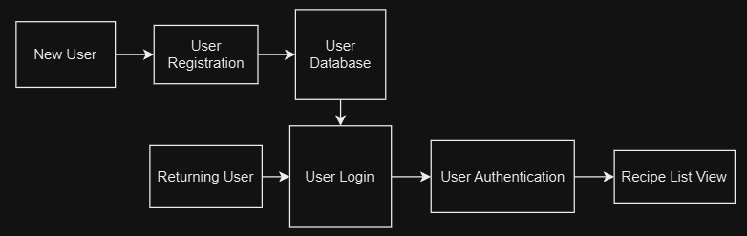

New users will enter their information into the registration form which will be saved to the user database. Returning and registered users will enter their information into the login form, which will then be used for user authentication. After the login information is authenticated, the user will gain access to the application and see their recipe home page.

**Recipe and Ingredient Management**

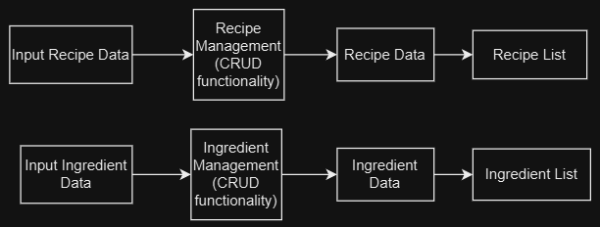

When a user inputs a new recipe or ingredient or performs other management functionality, the information will be sent to the backend where the functions are performed. The database will then be managed based on the user input and the recipe/ingredient list will be updated.

**Recipe Generator**

When using the recipe generator, the user will input their preferences such as available ingredients. The recipe generator will take this information and compare it to the RecipeIngredient data table and output a generated recipe.

User Interface Design

Sitemap

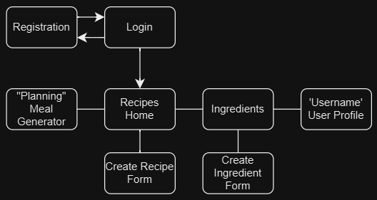

When accessing the application, the user begins at the login page. From there they may navigate to the registration page where they will register then return to the login page. After logging in they are directed to their recipe home page where they will be able to navigate between pages using a navigation bar.

**Registration**

The registration page will require an unregistered email address and a unique username. All users will be required to create a new account before accessing the application.

Login

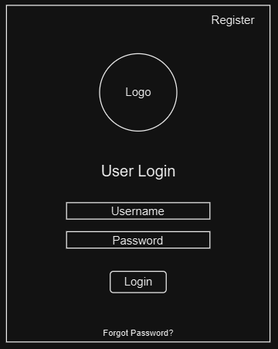

To login the user will be required to input their username and password. Spring security will support user authentication for successful login.

Recipe Home Page

Upon logging into the application, the user will be directed to their recipe home page. On this page the user will view their recipes in a list format with a search feature to quickly find recipes. The page also supports editing, deleting, and creating a new recipe.

**Create Recipe Form**

The create recipe form, accessed from the recipe home page, allows users to add new recipes to their list. Ingredients may be picked from the ingredients database or new ingredients can be added. Descriptors will allow the recipe to be quickly searched at a later time.

**Ingredients Page**

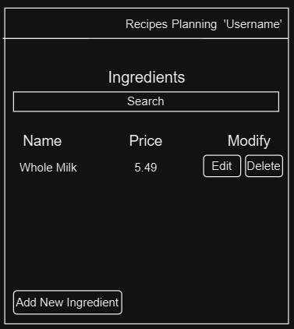

The ingredients page allows users to see their ingredients in a list format. On this page ingredients can be created, edited, or deleted.

**Create Ingredient Form**

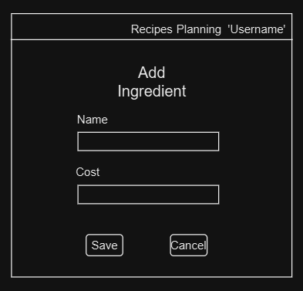

The add ingredient form allows users to save new ingredients as well as their price range for use in future recipes. After saving the new ingredient, the user is directed back to the ingredients page.

**Recipe Generator Page**

The recipe generator page allows users to enter a price range and individual ingredients to generate a recipe from the users’ existing recipes.

**User Profile Page**

In the user’s profile page, the user is able to view and edit their personal information. The user is also able to submit user feedback using the form on the bottom of the user profile page.

Reports Design

User Feedback

User feedback will be collected upon user submission of the feedback form on the information page in the application. Each feedback will be given its own feedback ID and will also include the users UserID. The report will also include a time stamp for the submission, the feedback itself, and the status of the submission.

|  |  |
| --- | --- |
| User Feedback | |
| Feedback ID | FeedbackID |
| User ID | UserID |
| Submission Date | YYYY-MM-DD |
| Feedback | Text |
| Status | Received/Processed/Resolved |